**《Fundamentals of Electric Circuits》homework CH.15**

**15.9 Determine the I aplace transforms of these functions:**

**(a) *f(t)= (t - 4)u(t - 2)***

**(b)*g(t) = 2e-4tu(t - 1)***

**(c)*h(t) = 5 cos(2t - 1)u(t)***

**(d)*p(t)=6[u(t - 2) - u(t - 4)]*** (20’)

**15.22 Find the Laplace transforms of the functions in Fig. 15.34.** (20’)

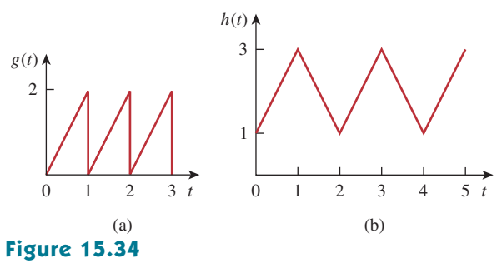

**15.25 Let**



**(a) Use the initial and final value theorems to find *f(0)* and *f(∞)*.**

**(b) Verify your answer in part (a) by finding *f(t)*,using partial fractions.** (20’)

**15.31 Find *f(t)* for each *F(s)*:**

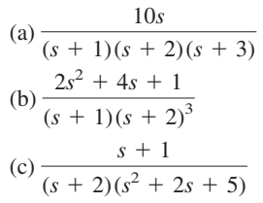(20’)

**15.34 Find the time functions that have the following Laplace transforms:**

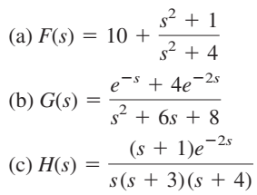(20’)